**MODULE 3**

**Business and Career Transformation Through AI**

**AI Agents**

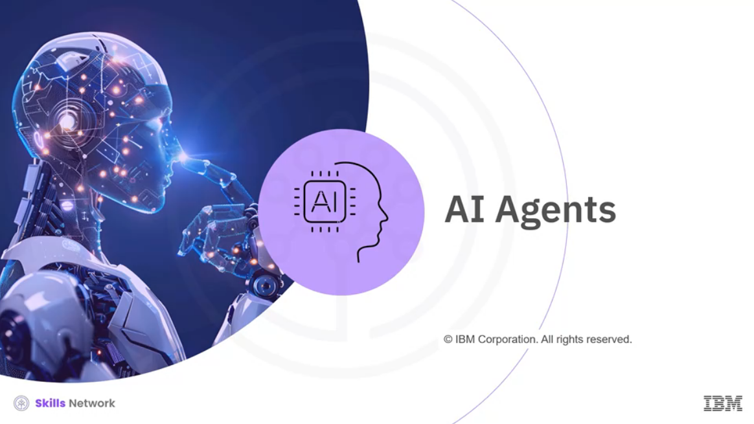

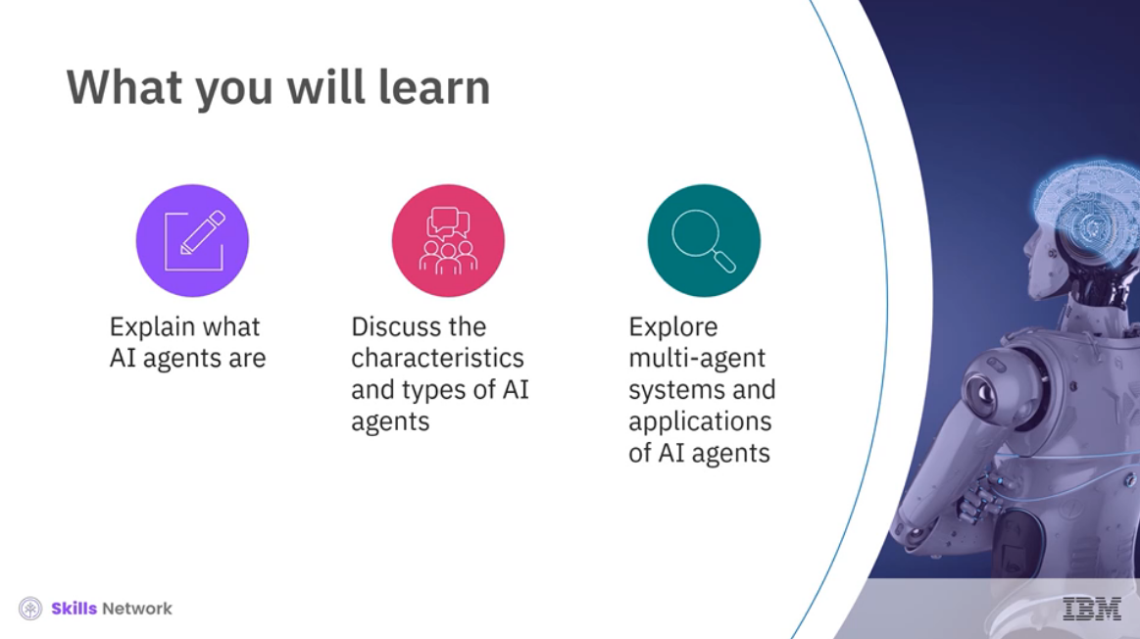

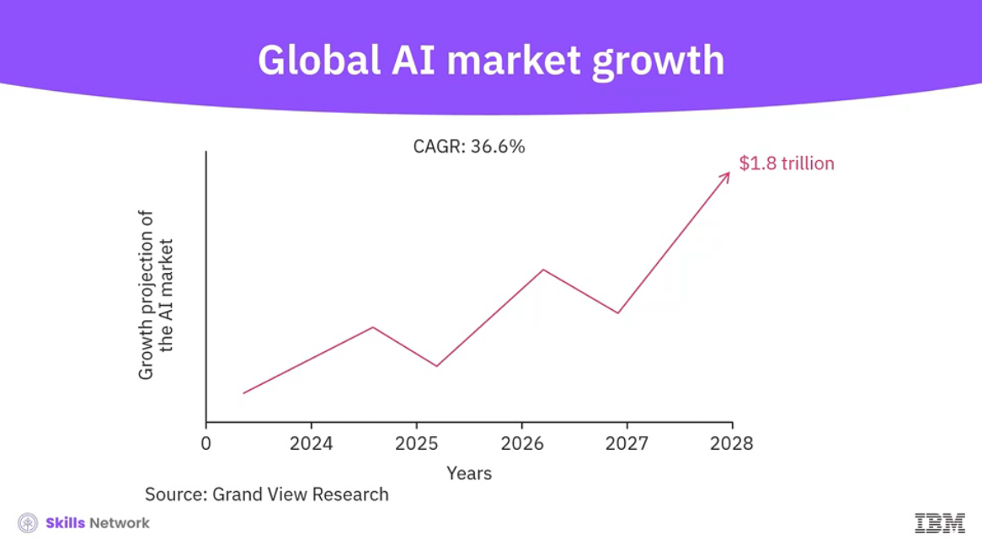

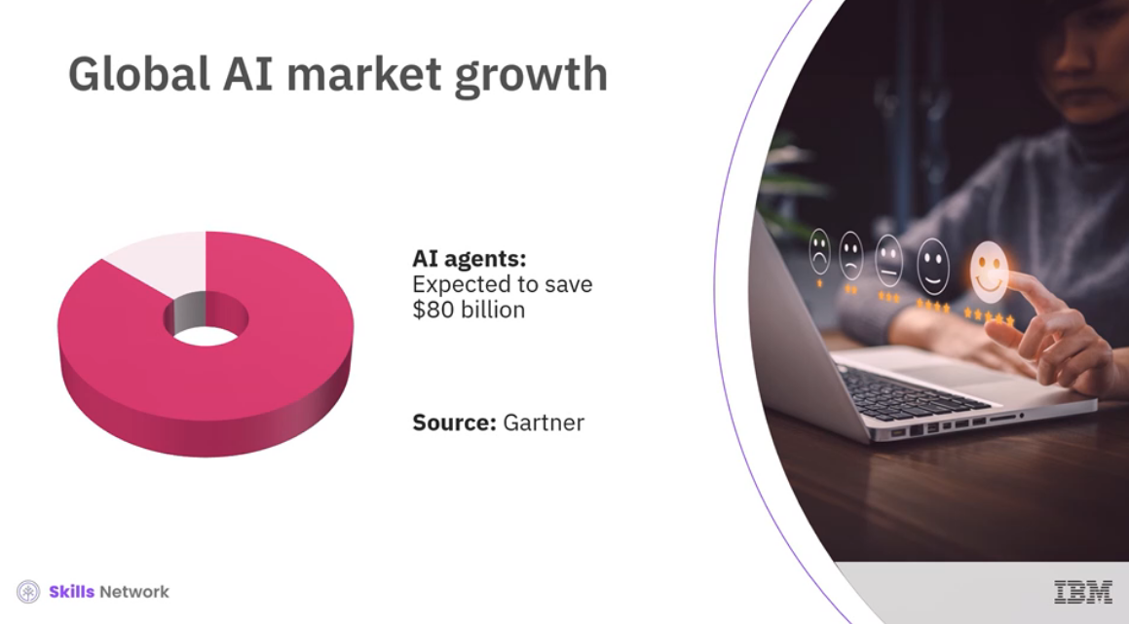

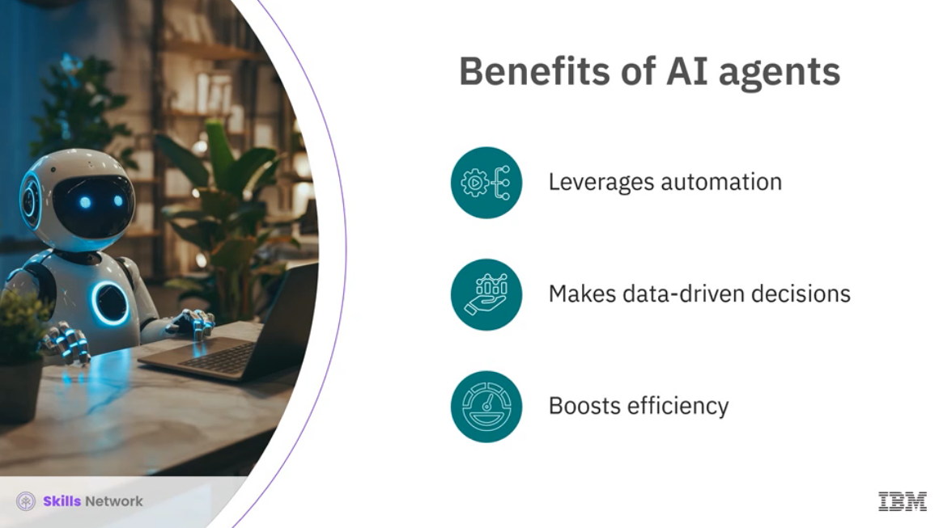

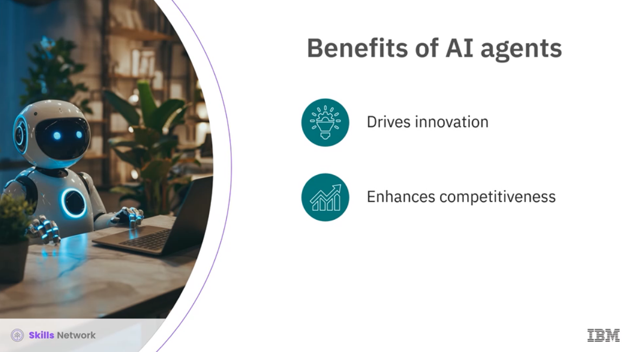

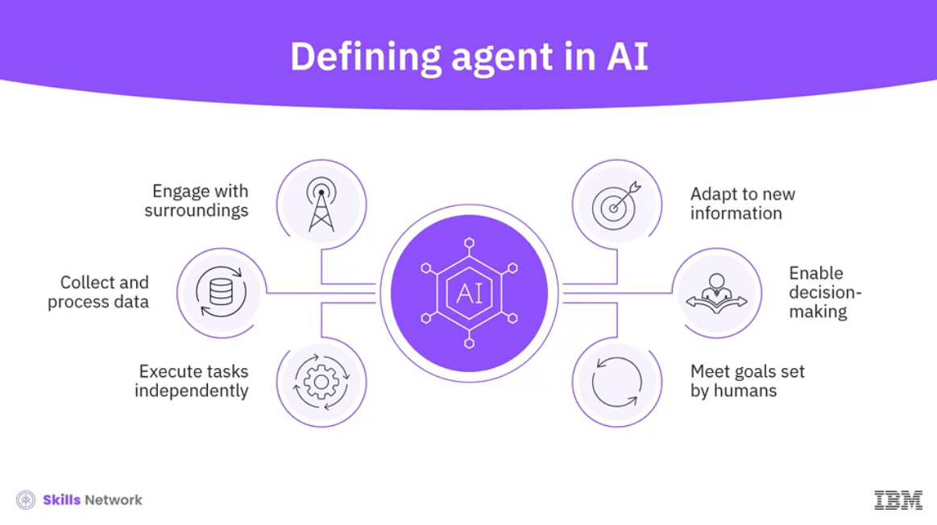

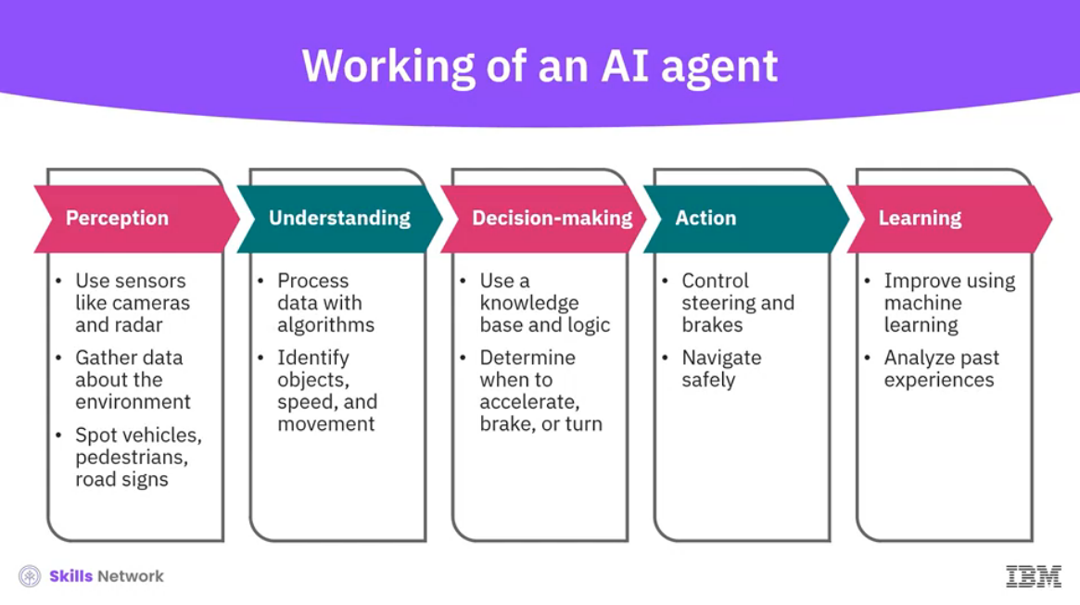

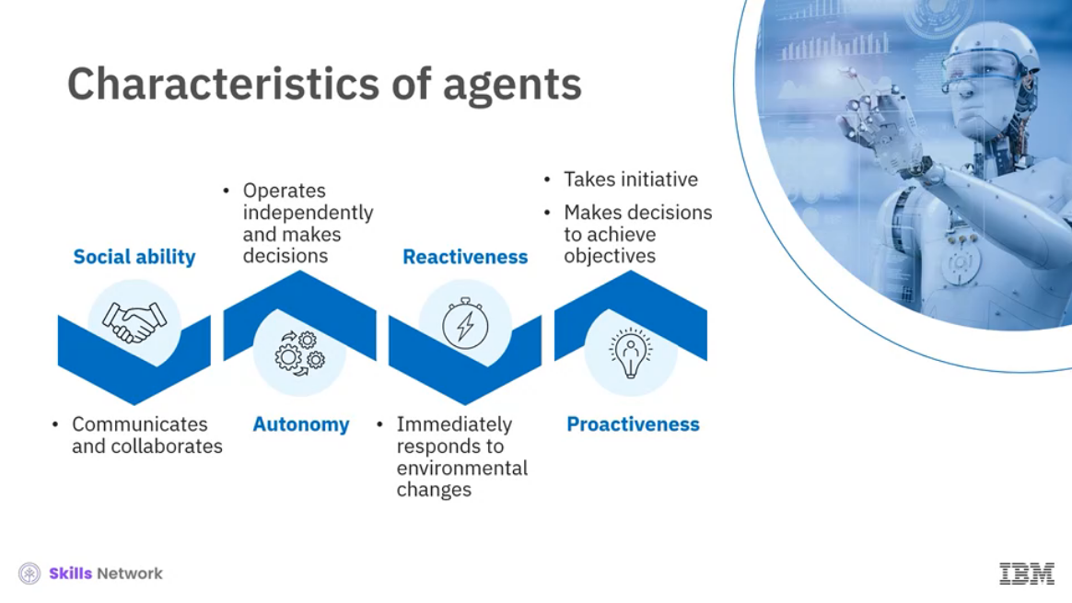

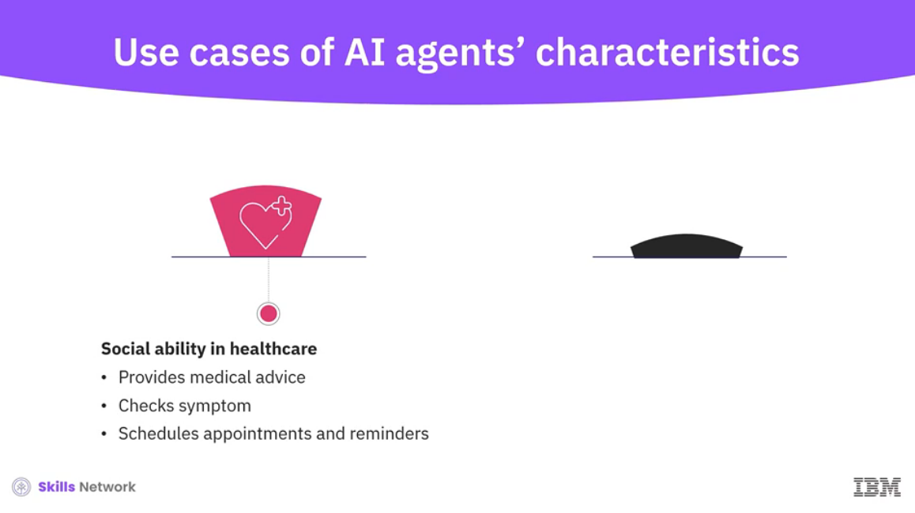

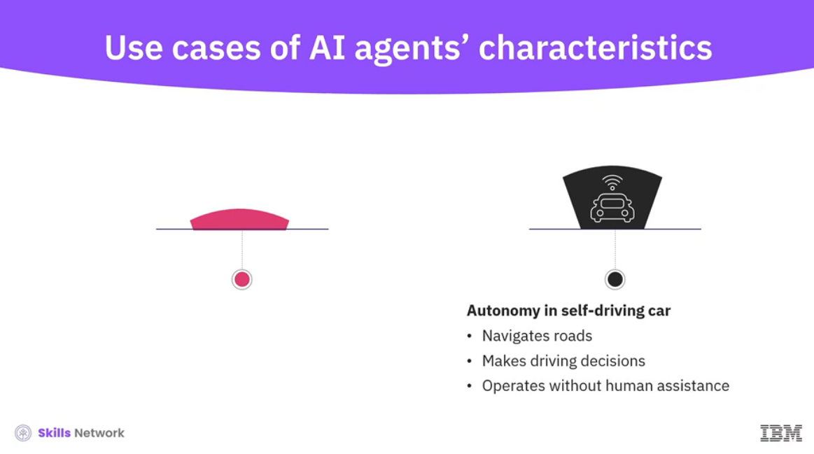

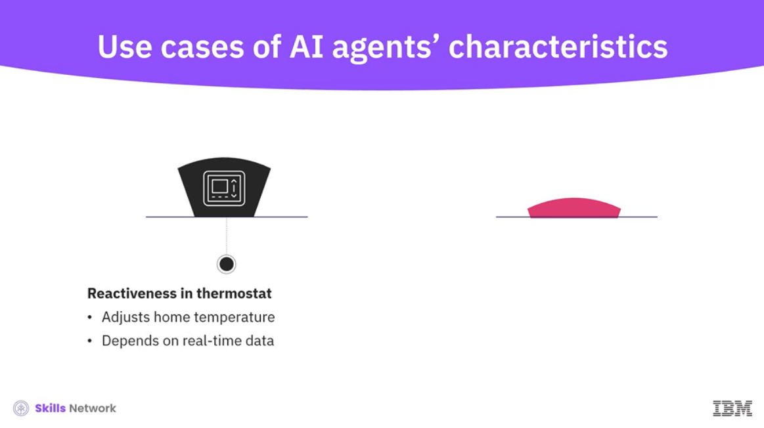

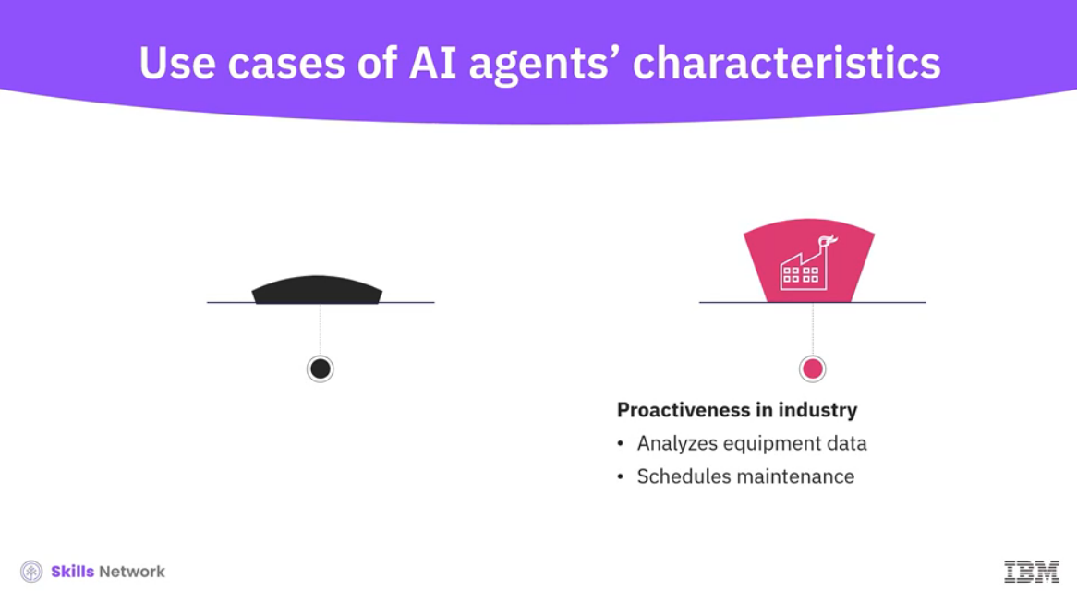

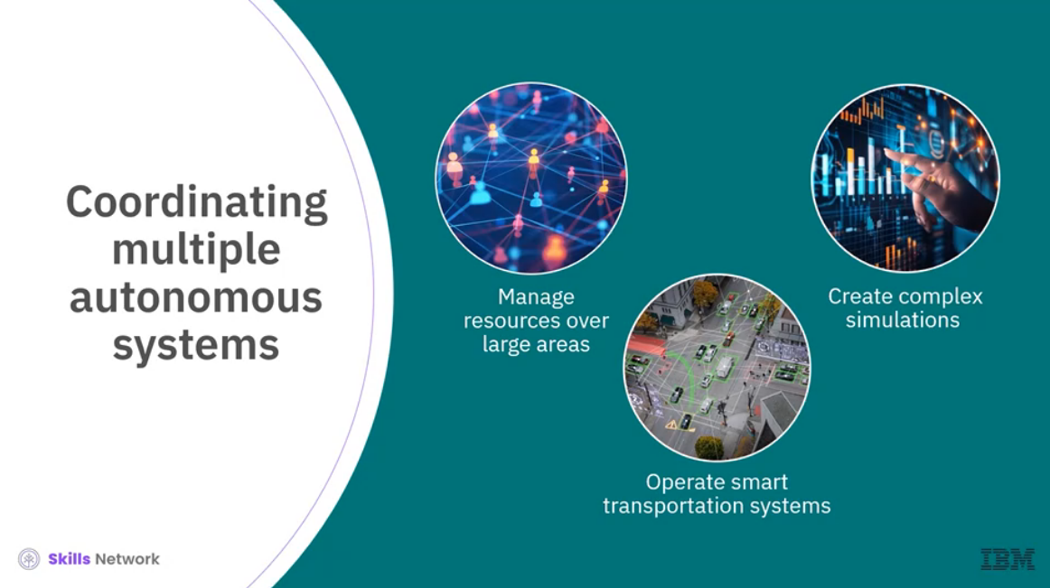

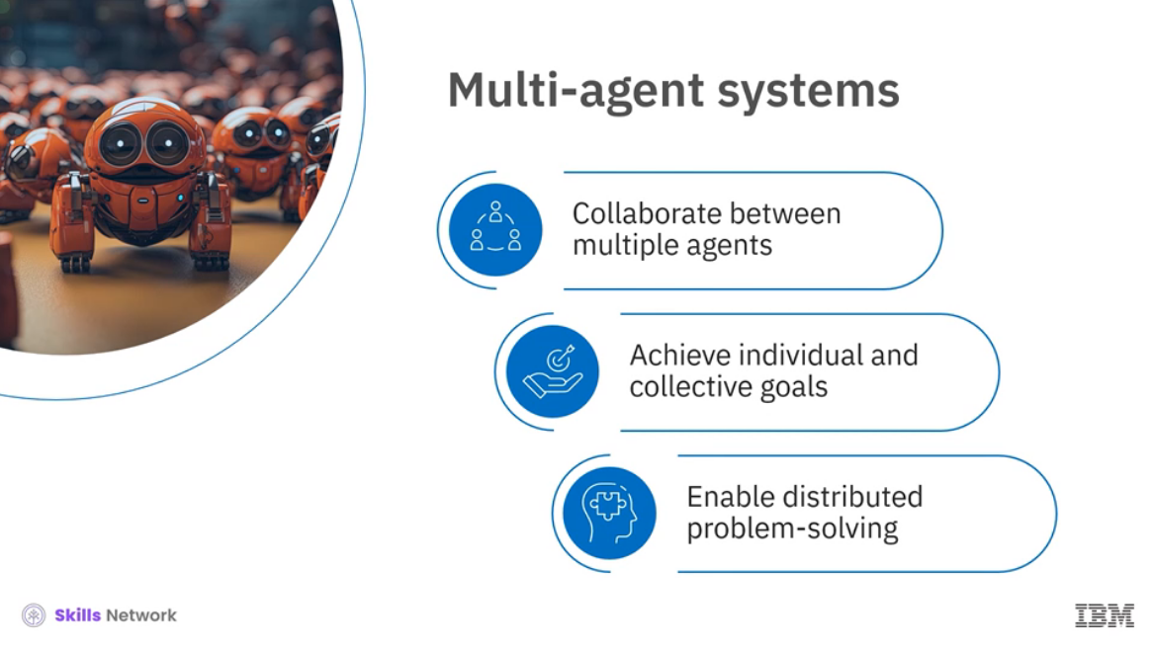

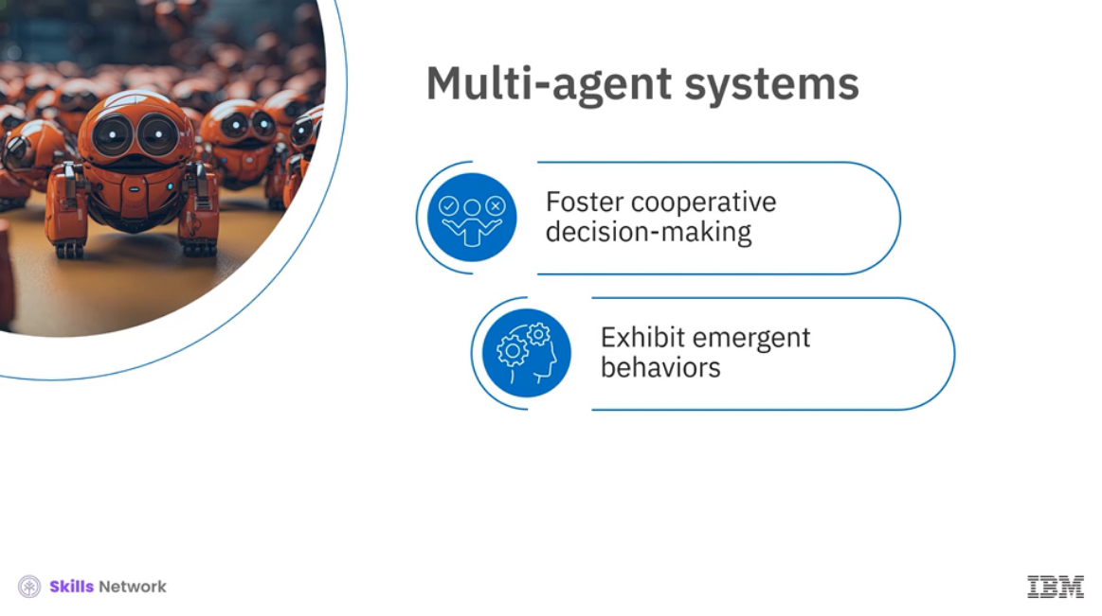

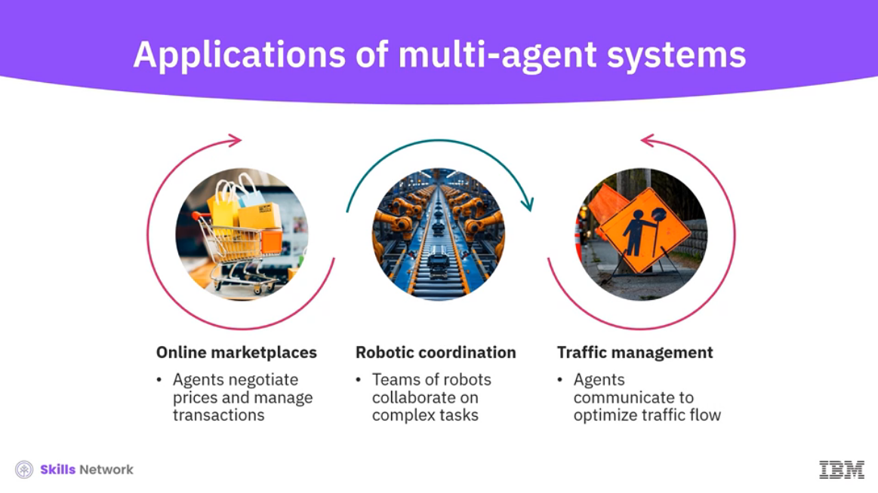

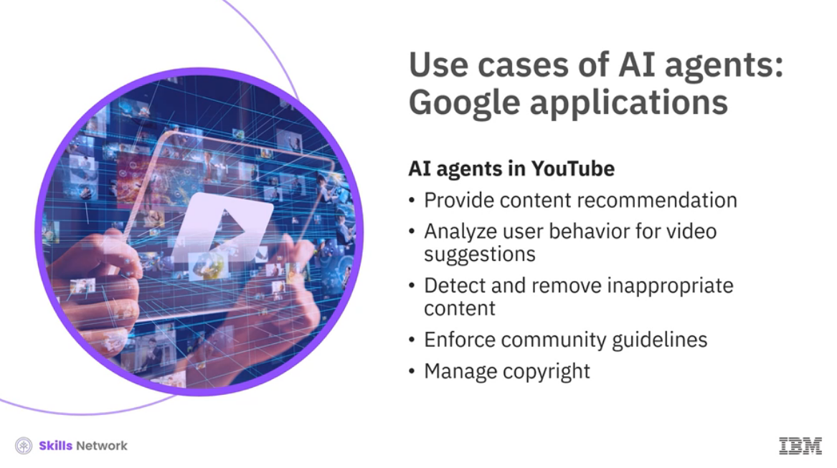

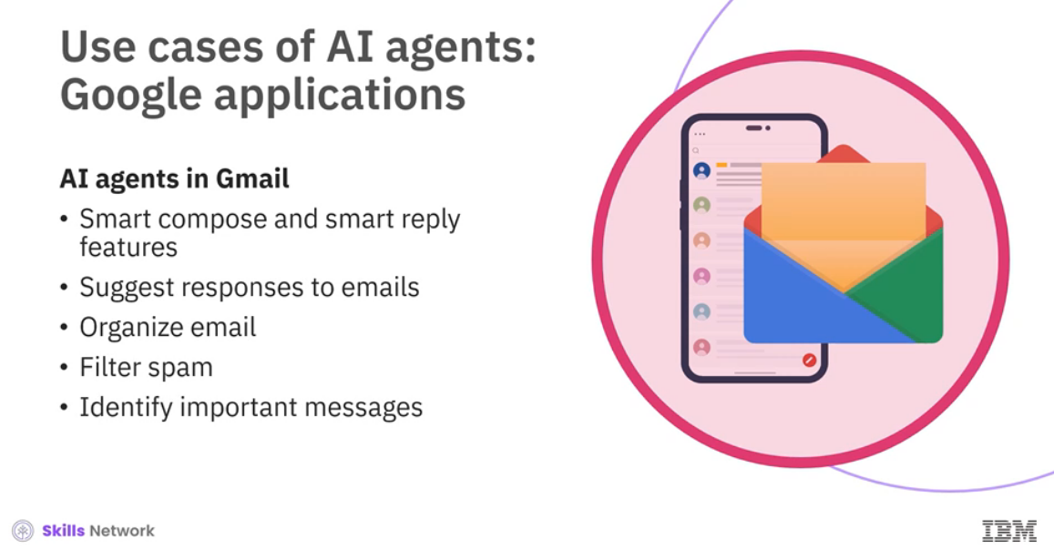

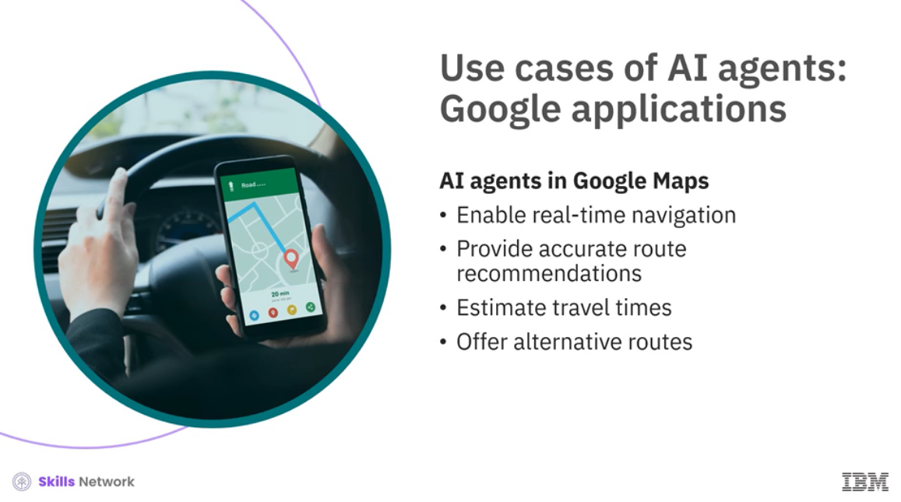

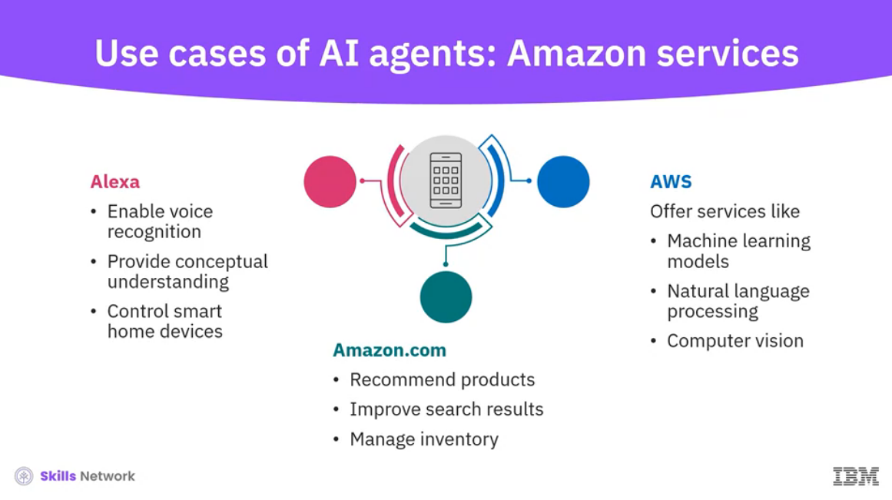

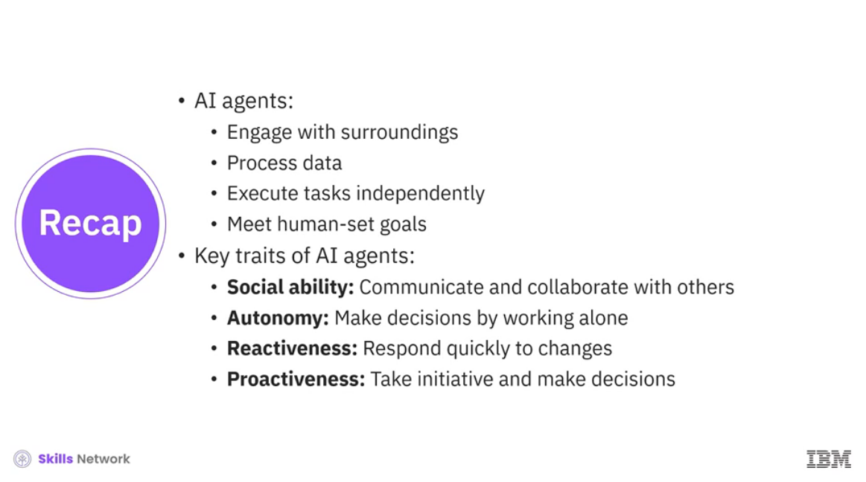

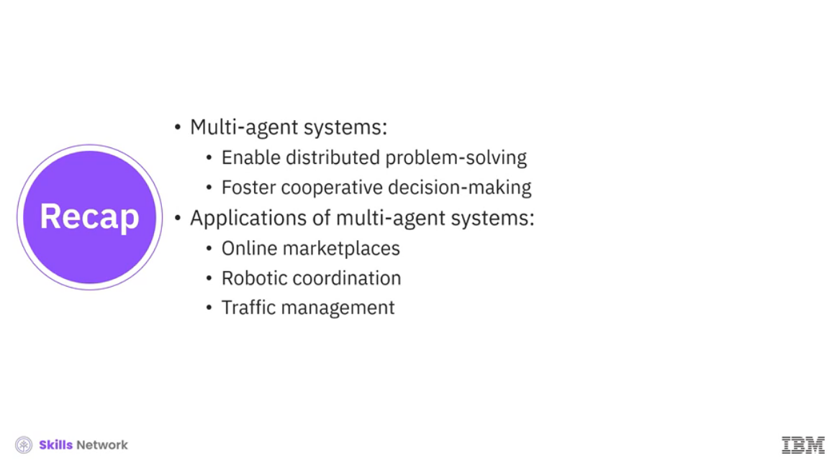

______________________________________________________________________________

**What are AI Agents?**

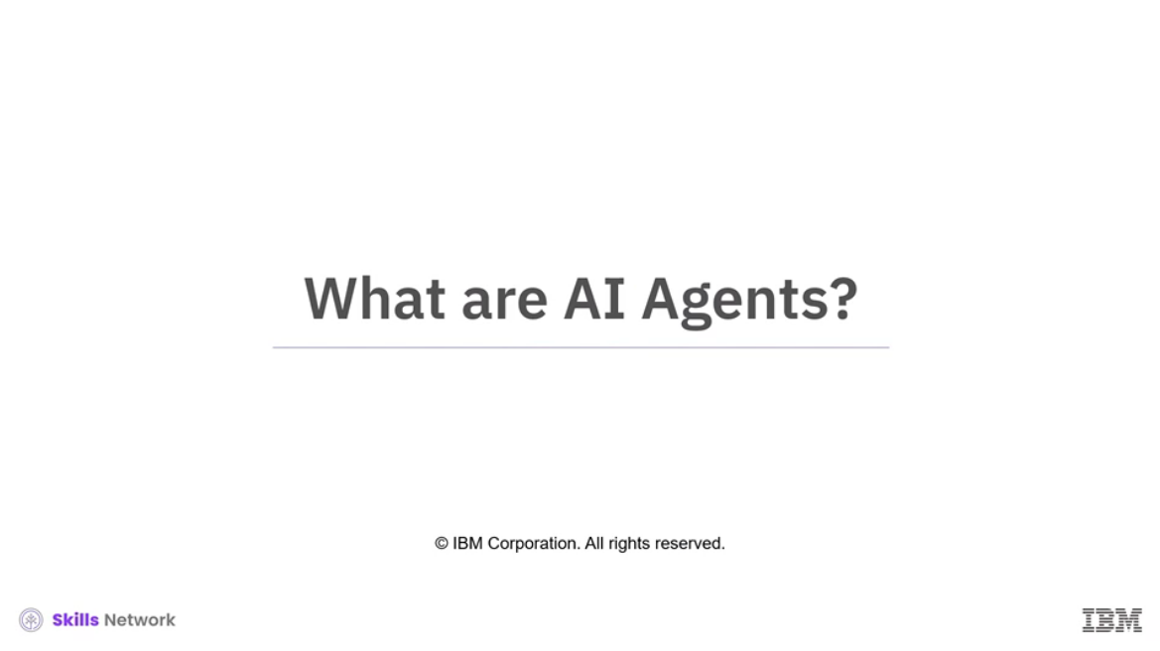

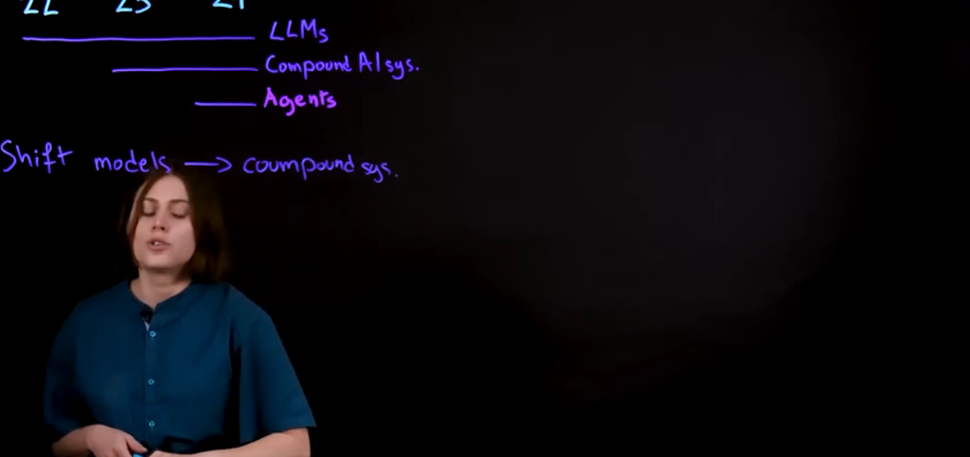

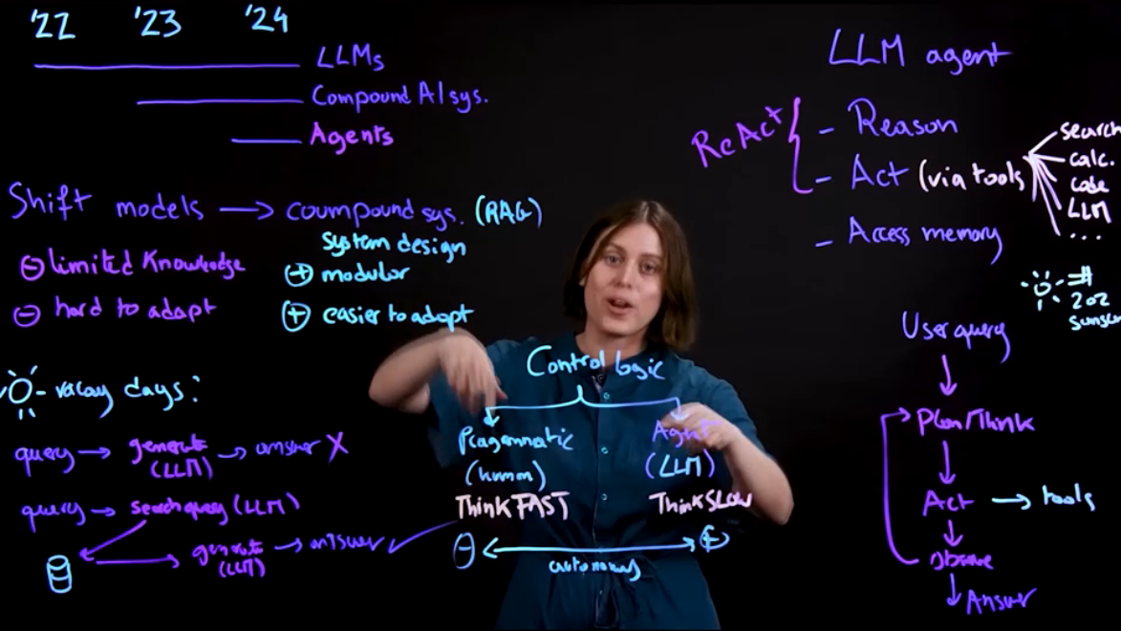

______________________________________________________________________________

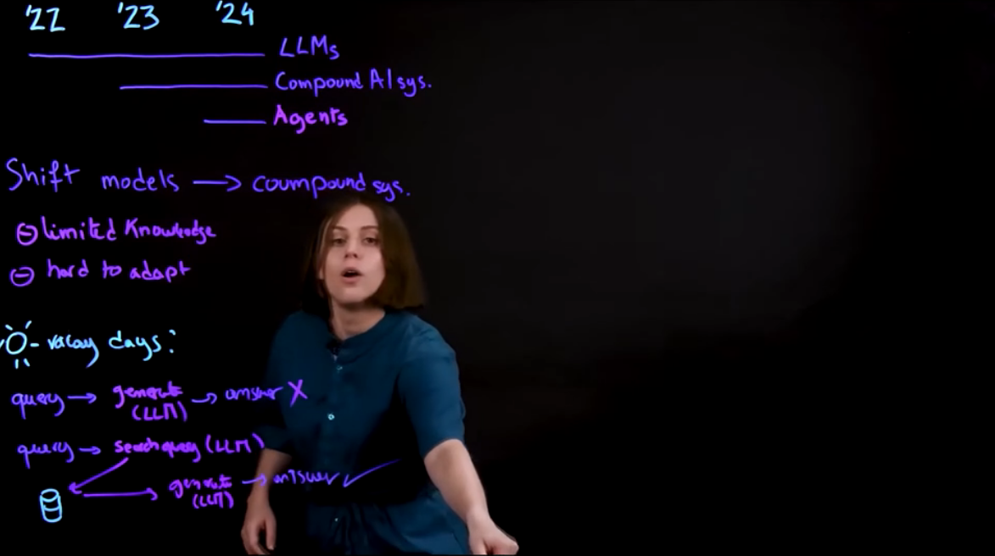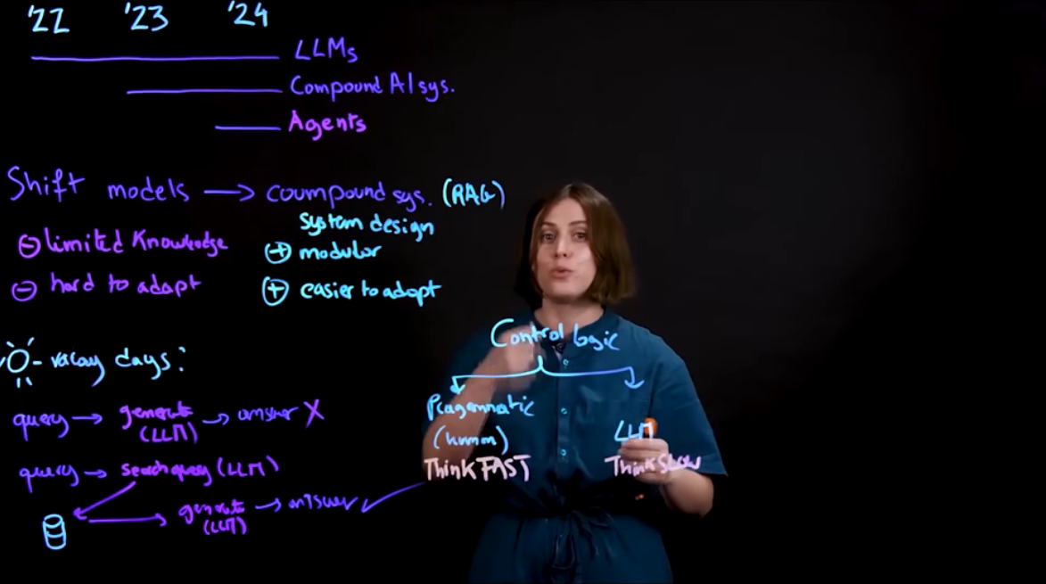

______________________________________________________________________________

**Robotics and Automation**

